Firebreak Notice 2022
October 2022

Firebreak Notice 2022
  - Notice to the Owner or Occupier of Land
Section 33 of the Bushfires Act 1954
Pursuant to the powers contained in Section 33 of the Bush Fires Act 1954, you are hereby required on or before the 1st day of January, (or within fourteen days of becoming owner or occupier of land should this be after the 1st day of January), to clear and maintain mineral earth breaks and reduce the fuel load from the land owned or occupied by you as specified hereunder and to have the specified land and firebreaks clear of all flammable material all year round.

If I don’t comply – what penalties can be applied?
Properties will be inspected on an annual basis to ensure compliance. If a property is not compliant on first inspection the owner/occupier will be contacted and given 14 days from notification to comply.
People who do not comply with the Notice may be issued with an infringement Notice ($250) or prosecuted with a penalty up to $2,500.
In addition to any enforcement action if the owner/occupier does not complete the specified work, pursuant to Sec.33(4), the Shire may enter the property to complete the required work. The subsequent costs may be recovered from the owner/occupier of the land.

Firebreak Variations
If it is considered impractical to comply with this Firebreak Notice and the specified requirements for the land you own or occupy you may apply to Council in writing for a variation.
Applications to Council are to be submitted by the 30th of August each year. If the application is unsuccessful you must comply with the requirements of this notice.
Applications are to be forwarded to soa@ashburton.wa.gov.au posted to PO Box 567 Tom Price WA 6751

Summary of Specified Requirements
Note: The specified requirements include mining and/or construction accommodation facilities

Land In Town Sites
Land area 2000m²  (½ acre) or less | All flammable material is reduced over the whole of the land.  Grasses slashed to a height 75mm and removed
Land area exceeding 2000m² | All flammable material is reduced within a 20-metre perimeter of any building on the land  Grasses slashed to a height 75mm and removed: or  A minimum 3-metre-wide mineral earth break cleared of all flammable material is installed immediately inside and along the boundaries of the land.

Land Outside Town Sites
Land only | A minimum 5-metre-wide mineral earth break cleared of all flammable material is installed immediately inside and along the boundaries of the land.
For all buildings | Two 5-metre-wide mineral earth breaks cleared of flammable material must surround the buildings:  The inner mineral earth break is to be sited 20 metres from the perimeter of the building(s)  The outer mineral earth break is sited 100 metres from the inner mineral earth break.

Additional Works
Additional works considered necessary may be required by an Authorised Officer and will be advised in writing to the owner/occupier.
If the requirements of this Notice are conducted by burning, such burning must be in accordance with the relevant provisions of the Act.
A prescribed burning plan may be required for any proposed burning activity.

What does a compliant property look like?

Compliant Residential Property
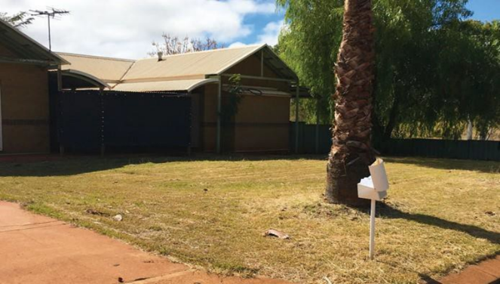

Compliant Vacant Land
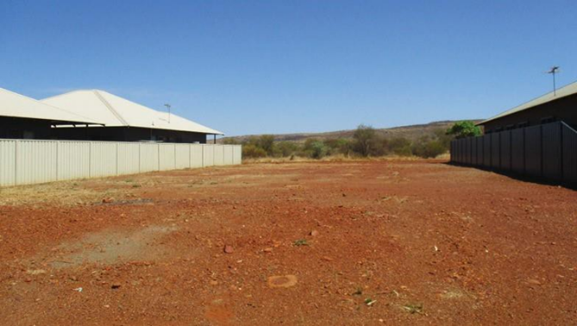

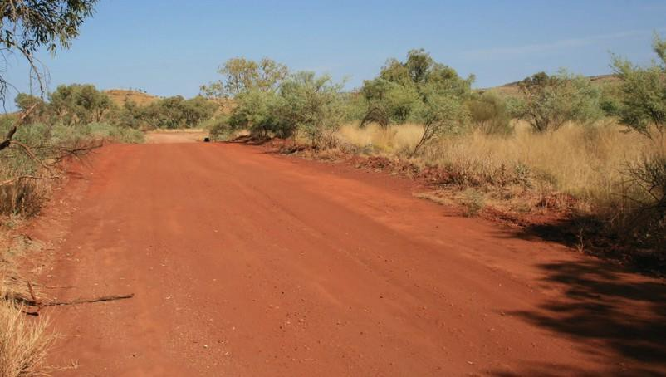
Compliant Mineral Earth Break

Powerlines & power transmission lines In Town Sites
Power and transmission lines | Power line infrastructure must be maintained as per the guidelines issued by Energy Safety within the Department of Mines, Industry Regulation and Safety
Power lines conducting less than or equal to 33,000 volts | Ground fuel must be cleared to a minimum of 5 metres on either side of a centre line created by the poles/towers.  The minimum total cleared area is 10 metres in width  The area is maintained to the mineral earth break standard.
Power transmission lines conducting greater than 33,000 volts | - A 5-metre-wide mineral earth break is maintained on either side of the widest point of the arms/cross arms on the pole/tower  - A 5-metre-wide mineral earth break is maintained directly under the power line corridor

Water supply pipelines & infrastructure
Water supply pipelines and associated infrastructure | - A 5-metre-wide mineral earth break is cleared on either side of the pipeline and associated infrastructure  - Clear of flammable material.  Access points installed and maintained for Emergency Services access

Explosives magazines & storage areas
Flammable Materials | A 15-metre-wide perimeter cleared to bare earth around the magazine/storage areas

Fuel storage areas - Stockpiled flammable material - Haystacks
Fuel storage areas | A 10-metre-wide area cleared of flammable material around any fuel type storage area regardless of size, full or empty
Stockpiled flammable materials  Haystacks | - A 10-metre-wide mineral earth break installed around any:  - Stockpiled flammable materials  - Haystacks

Restricted Burning Period
The Shire of Ashburton is in a RESTRICTED BURNING period all year round.
Camping and Cooking Fires are not permitted for use when:
- When the Fire Danger rating is Extreme or above.
- When a Total Fire Ban is in place
- Where campgrounds prohibit camping and cooking fires at any time.
- On public land that is not a designated area.
Camping and Cooking Fires are permitted when:
- When the Fire Danger Rating is Moderate, or no rating is indicated
- On private property when the Fire Danger Rating is High, between 6:00 pm and 12:00 am with consent from the owner/occupier and a Permit issued by an Authorised Fire Control Officer.
- Where there is a 3-metre-wide area cleared of flammable material around the fire
- One able-bodied person capable of extinguishing the fire must be in attendance.
- Sufficient water and fire suppression tools are readily available to extinguish the fire

Total Fire Ban
- A Total Fire Ban (TFB) is declared on days when the Fire Danger Rating is Extreme based on weather conditions that will impact fire suppression activities.
- The need for the ban is assessed throughout the day and the ban may be revoked if weather conditions ease.
- A Total Fire Ban is declared the evening before it is to take effect.
- Check the Emergency WA website after 6 pm for declared bans in your area - www.emergency.wa.gov.au
- When a TFB is declared it prohibits the lighting of any fires in the open air and any other activities that may start a fire.
- The ban includes all open-air fires for the purpose of cooking or camping. It also includes incinerators, welding, grinding, soldering, or gas cutting.

Burning garden refuse during restricted burning times

1. A person must not burn garden refuse at a place (other than a rubbish tip) during the restricted burning times for that place unless it is burned: | in an incinerator in accordance with subsection (2); or  on the ground in accordance with subsection (3).
2. Garden refuse burned in an incinerator is burned in accordance with this subsection where: | the incinerator is designed and constructed to prevent the escape of sparks or burning material; and either  the incinerator is situated not less than two (2) metres from any building or fence; or  if the incinerator is less than two (2) metres from a building or fence, the Council or its Authorised Officer has given written permission in writing for the incinerator to be used; and  there is no flammable material within two (2) metres of the incinerator while it is in use; and  at least one person is always present at the site of the fire until it is completely extinguished: and  the fire is no longer required, the person ensures that the fire is completely extinguished by the application of water or earth.
3. Garden refuse burned on the ground is burned in accordance with this subsection where: | there is no flammable material (other than that being burned) within 5m of the fire at any time while the fire is burning; and  the fire is lit between 6:00 pm and 11:00 pm and is completely extinguished before midnight on the same day; and  at least one person is present at the site of the fire until it is completely extinguished: and  when the fire is no longer required, the person ensures that the fire is completely extinguished by the application of water or earth.

4. The Council or Authorised Officer must not give permission under subsection 9.1.(b)(ii) unless it is satisfied that the use of the incinerator is not likely to create a fire hazard

Permit to Burn
A permit to burn is required before lighting a fire in the Shire all year unless exempt by this notice or is subject to conditions before ignition is permitted.
Bush Fire Permits can be obtained by contacting an authorised Fire Control Officer (FCO). Contact the Shire of Ashburton for information on an FCO near your location
Please note you can only apply to one FCO for a permit within the Shire for your location. If a permit is refused by the FCO it is illegal to ask another FCO for the same permit
Have the following information ready when applying:
- Location of the proposed burn?
- Size of the proposed burn?
- Type of material to be burnt?
- What is the location of the burnt?
- Have neighbours been advised?
- What are the resources required for you to manage the burn?

Please Note
Prior to ignition, you must notify:
- Your neighbours
- The Chief or Deputy Chief Bushfire Control Officer
- The Dept. for Biodiversity, Conservation & Attractions if the planned burn is within 3kms of their managed lands

End of Document

