PARABURDOO Christmas Lights Competition 2021
Registration Form

Paraburdoo’s Annual Christmas Light Competition
People’s Choice Award 2021 - Cash Prize: $300
Judge’s Choice Award 2021- Cash Prize: $300
Best 1st Time Entry Award- Cash Prize: $250

- Registrations must be completed by 4pm Wednesday 24th November 2021
- Voting opens Friday 26th November to Wednesday 8th December 2021
- Winners announced on the Shire of Ashburton Facebook page, Thursday 9th December 2021

- Your Details

Name:

Address:

Email:

Phone:

TERMS & CONDITIONS OF ENTRY
- Entry is FREE and only available to residents within Paraburdoo.
- Entry forms need to be completed and submitted before24th November 2021.
- The Paraburdoo Christmas Lights Competition will be judged during self-guided walk/drive tours.
- Voting will be open from 26th November – 8th December 2021.
- All entrants agree to allow organisers to take and publicise photos of their display in print, digital and social media, including flyers and promotional material.
- The decisions are final, and no correspondence will be entered into account.
- Electrical safety is paramount and must be exercised at all times. Misuse of electricity could lead to your disqualification from the competition.
- Entrants are not to use the footpath, electricity poles, or any property outside their boundary for any purpose of their display.
- The organisers and sponsors accept no responsibility for damage, injury, or theft which may occur as a result of your entry into this competition.
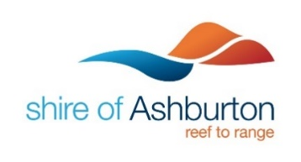
- Voting will close at 4pm 8th December 2021. The winners will be posted on the Shire of Ashburton website and social media.

