PANNAWONICA Christmas Lights Competition 2021
Registration Form

Pannawonica’s Annual Christmas Light Competition
People’s Choice Award 2021
- Tundra Haul Hard Cooler (valued at $599)
- Cash Prize: $300
Judge’s Choice Award 2021
- Tahwalhi Palm Beach Inflatable (valued at $499)
- Cash Prize: $300
Best 1st Time Entry Award
- Coolcarbana 5 – Shade & 2 lounge package (valued at $363)
- Cash Prize: $250

- Registrations must be completed by 4pm Friday 26th November 2021. They can be dropped at the town library during open hours or emailed to: pannaeventsandactivities@ashburton.wa.gov.au
- Voting opens Monday 29th November to Wednesday 8th December 2021
- Winners announced at the Rio Tinto Christmas Party on the 10th December and on the Shire of Ashburton Facebook page.

- Your Details

Name:

Address:

Email:

Phone:

TERMS & CONDITIONS OF ENTRY
- Entry is FREE and only available to residents within Pannawonica.
- Entry forms need to be completed and submitted before 4pm Friday 26th November 2021.
- Registrations can be dropped at the town library during open hours or emailed to: pannaeventsandactivities@ashburton.wa.gov.au
- The Pannawonica Christmas Lights Competition will be judged during self-guided walk/drive tours.
- Voting opens Monday 29th November to Wednesday 8th December 2021. A map will be provided via social media with registered houses for viewers.
- All entrants agree to allow organisers to take and publicise photos of their display in print, digital and social media, including flyers and promotional material.
- The decisions are final, and no correspondence will be entered into account.
- Electrical safety is paramount and must be exercised at all times. Misuse of electricity could lead to your disqualification from the competition.
- Entrants are not to use the footpath, electricity poles, or any property outside their boundary for any purpose of their display.
- The organisers and sponsors accept no responsibility for damage, injury, or theft which may occur as a result of your entry into this competition.
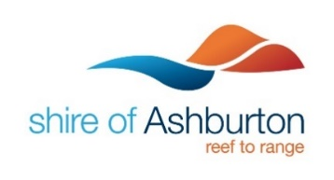
- Voting will close at 4pm 8th December 2021. The winners will be posted on the Shire of Ashburton website and social media.

