Onslow Christmas Lights Competition 2021
Registration Form

Onslow’s People’s Choice Award 2021 - Cash Prize: $250

- Registrations must be completed by 4pm Friday 26 November 2021
- Voting opens Monday 29 November to Friday 10 December 2021
- Winner announced at the Onslow Community Christmas Festival, Saturday 11 December 2021

- Your Details

Name:

Address:

Email:

Phone:

TERMS & CONDITIONS OF ENTRY
- Entry is FREE and only available to residents within Onslow.
- Entry forms need to be completed and submitted before 26 November 2021.
- The Onslow Christmas Lights 'People's Choice Award' will be judged during self-guided walk/drive tours.
- Voting will be open from 4 December - 20 December 2021.
- All entrants agree to allow organisers to take and publicise photos of their display in print, digital and social media, including flyers and promotional material.
- The judges’ decisions are final and no correspondence will be entered into.
- Electrical safety is paramount and must be exercised at all times. Misuse of electricity could lead to your disqualification from the competition.
- Entrants are not to use the footpath, electricity poles, or any property outside their boundary for any purpose of their display.
- The organisers and sponsors accept no responsibility for damage, injury, or theft which may occur as a result of your entry into this competition.
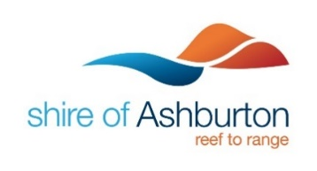
- Voting for the Onslow Christmas Lights 'People's Choice Award' will close at 4pm 10 December 2021. The winner will be announced at the Onslow Community Christmas Event. The winner's name will be posted on the Shire of Ashburton website and social media.

