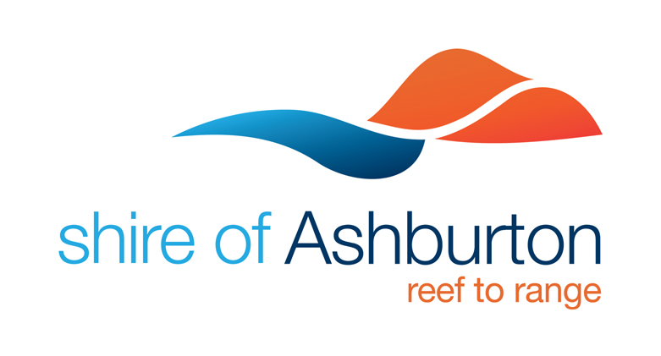
Media Release
23 September 2021

Onslow Art Selection Working Group seek community feedback

The Onslow Art Selection Working Group has been formed and have already held their initial meeting as they begin the process to deliver the Onslow Water Tank Mural Project.

Shire of Ashburton President Kerry White acknowledged those who had put themselves forward to be part of the working group.

“The working group, guided by Element Advisory, will represent the interests of Onslow’s community for the Water Tank Mural Project, assisting in reviewing artist submissions and providing a recommendation for the preferred artwork that will form the mural”, said Councillor White.

“The group are looking for community sentiment via an online survey so that they can listen to the feedback of the community in relation to community aspiration for the mural.

“The survey can be found at tinyurl.com/onslowtanks and is open until Friday 15 October 2021.

“An Expression of Interest for artists will open soon, giving artists three weeks to submit their response.

“It is envisaged that the Artist will be appointed before the end of the year with installation to commence April 2022.”

For media information contact:
Alison Lennon, Manager Media and Communications, M: 0409 314 140 | E: alison.lennon@ashburton.wa.gov.au

