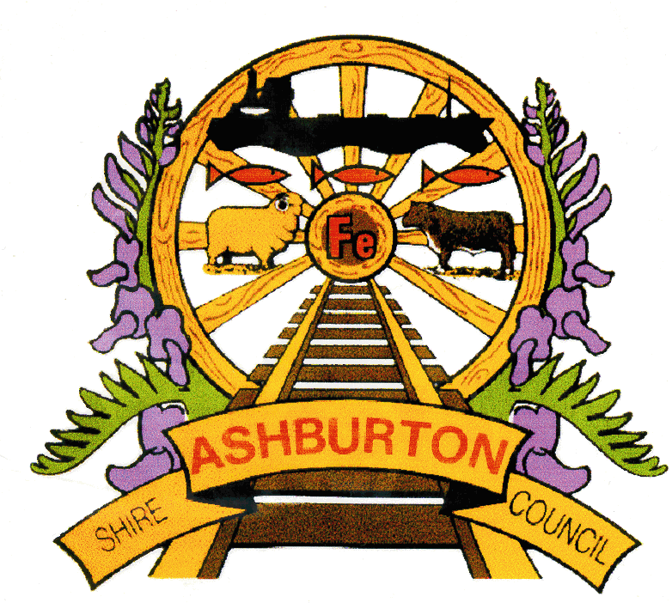
Policy No: CORP_ORG

Policy Name: REC08 COMMUNITY DONATIONS, GRANTS
AND FUNDING POLICY

File No: REC08
OR.CM1

Policy Purpose: To provide compliance with the Local Government Act 1995

To outline the criteria for offering not-for-profit community, sporting, cultural and service groups and associations, and individuals financial assistance to deliver high quality programs, community events, facilities and/or services that directly benefit the residents of the Shire of Ashburton.

To support community initiatives that strengthen the sense of community connectedness and sustainability in the Shire of Ashburton

To enable the Shire to have a consistent and equitable approach in how it supports community and sporting groups

To give clear guidelines, direction and information to community and sporting groups who wish to seek funding from the Shire of Ashburton

Principles / Framework: Shire of Ashburton 10 Year Community Strategic Plan 2012 -2022 “Living Life”

Goal 01- Vibrant and Active Communities

Objective 01- Connected, Caring and Engaged Communities

Objective 02- Active People, Clubs and Associations.

Application: General public
Statutory Environment: Section 6.7(2) Local Government Act 1995
Minute No: 11.11.28
Approval Date: Adopted OCM 18 November 2008
Reviewed OCM 16 July 2014

GENERAL CONDITIONS AND CRITERIA
- The applicant is to reside or operate within the Shire of Ashburton, OR be able to show a direct and substantial benefit to residents within the Shire of Ashburton
- Applications that are not connected with, and do not show direct benefit to, the Shire of Ashburton are unable to be considered
- Assistance is not available retrospectively
- All applications are to be in writing, and on the correct application form (Community Support Grants are to be submitted on SOA CD 039 Community Grants Application Form)
- Funds are to be used for the purpose for which they were approved
- Funds are to be used solely for the purpose of providing benefit to the residents of the Shire of Ashburton
- Due recognition is to be given to the Shire of Ashburton for its contribution towards the project/facility/activity/event
- Where required (Community Support Grants) applicants are to complete an acquittal report

AREAS OF ASSISTANCE
- SMALL ASSISTANCE DONATIONS - MAXIMUM $500 PER ORGANISATION/INDIVIDUAL PER FINANCIAL YEAR
- Small Assistance Donations may be provided for any purpose where an organisation/individual has not/could not otherwise have applied to the Shire of Ashburton for any other form of donation.
- Applicants may apply more than once in a financial year providing the total amount requested/donated does not exceed $500 (this includes cash and in-kind support such as donated venue hire)
- Applications can be submitted at any time, in writing, and can take up to 4 weeks to be processed – applicants are to allow sufficient time for this processing as donations are not approved retrospectively
- Donations for assistance with administrative and day-to-day running of groups and organisations are unable to be considered
- Local schools may apply for Small Assistance Donations
- If requested, financial statements showing that the donation was spent in accordance with the request are to be produced.

COMMUNITY SUPPORT GRANTS – MAXIMUM $2,500 PER ORGANISATION PER FINANCIAL YEAR
- Applications are to be made on the relevant application form (SOA CD 39) available from the Shire/Community Development Offices
- Applications can be for cash and/or in-kind contributions as long as the total amount is no more than $2,500
- Funding is only available to incorporated community and sporting organisations
- Applications are to be received before the advertised closing date. Late applications are unable to be considered
- Applicants can apply more than once each financial year as long as the total amount is less than $2,500 (this includes cash and in-kind donations such as venue hire)
- Applications are to be completed in full and signed by an Officer Bearer
- There are two funding rounds offered each year one in July (closing August) for projects from September to April, and one in February (closing March) for projects from April to August
- Applications are assessed by a panel consisting of one senior community development staff member and at least 2 Councillors, each from different wards.
- As part of the application process, applicants agree to submit an acquittal report within 4 weeks of the completion of the event/activity, containing
  - A detailed budget signed by the Treasurer and President of the organisation
  - An evaluation of the event/activity
  - Proof that the grant was expended according to the approved application
- Applications for events that could not have reasonably been anticipated within the advertised funding rounds are to be considered under Delegation
- Applications that could have been anticipated within the advertised funding rounds are unable to be considered (applicants in these situations are welcome to apply for a Small Assistance Donation)
- Decisions to allocate funding to a project is based on the following criteria
  - The extent to which the project directly benefits the residents of the Shire of Ashburton
  - Funding and/or contributions from other sources
  - Value for money

- DONATIONS TO SCHOOLS
- The Shire of Ashburton is committed to supporting local schools and automatically makes an annual donation to each school, within its boundaries, using the following calculation
  - Base amount of $1,000
  - Plus $1.00 for each high school student (Includes Year 7 students)
  - Plus $0.70 for each primary school student (excludes Year 7 students)
  - Plus $0.20 for each pre-primary student
- Student numbers are calculated using figures from the Department of Education
- Donations are paid in May each year
- Schools who receive a donation under this policy are also eligible to apply for Small Assistance Donations (eg for hire of venue for school functions, special events, or donations towards student prizes)

____________________________________ ______________________________________
[Signature] [Print Name]
Signed Shire President

Monitor and Review: Executive Manager, Community Development

Last Review Date OCM 16 July 2014
Next Review Date October 2016

This policy is to remain in force until otherwise determined by the Council or superseded.

